103.2 Group Project

Brief

We have been tasked as a group to re design and make a login and booking system for a new zealand based blood bank, this will be made inside a c++ console application, this application will need to include different users permissions, a functioning booking system and a useable and readable interface.

User Requirements

* User should be able to make an an account as an recipient, doner or admin
* The application Should have a readable interface and should be easy to navigate.
* There must be a way to change, add and remove personal user information.
* After 3 wrong login attempts it should loft the user out for a short time.
* The user should be able to book for blood donation,
* Should be able to look at their own details and information and change personal information.

Business requirements

* This application should be user tested and changed to suit any gathered information from the user testing.
* Any errors in the code should be discussed in a report, and fixed by the time of hand in
* We should use trello to communicate with the team and plan meetings or scrums; these should be partially documented.
* The task should be finished in 4 weeks by the set date of the 29th of june
* Thorough research into adjacent companies for inspiration

System requirements

* The console application should have a switch statement so users can select a login type (admin, donor or recipient) .
* Would likely use a system(“cls”) to keep the interface tidy and clear.
* Code should be tidy and well commented .
* Passwords and emails should be written too and accessed by the read and write functions to a csv file to store information and keep data secure.
* Should use namespace std ‘cin’ and ‘cout’ to take and display important information for menus
* Application runs without any error.
* All data types use proper naming conventions.

(uml diagrams)

Swot analysis on NZBlood

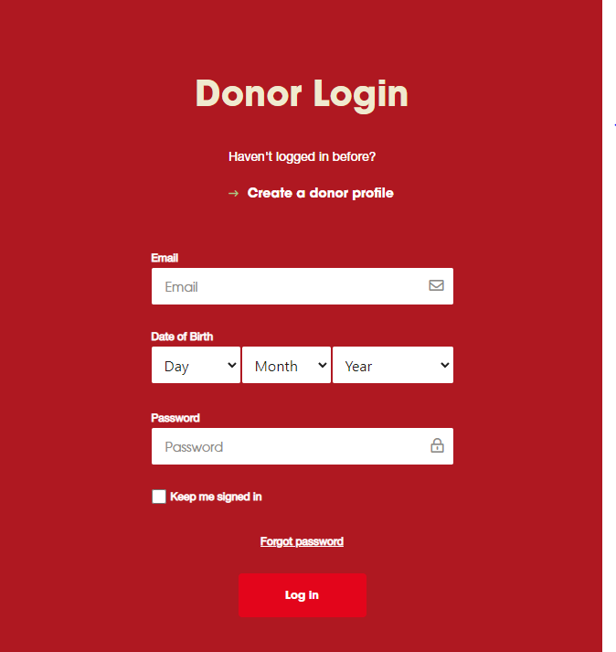

Throughout this analysis I will be looking into nz blood bank as a potential competitor and for any inspiration,

Strengths

* The site and login has a tidy and readable color scheme that is aesthetic and relevant.
* information on why and how you can donate blood, plasma and organs.
* Has import covid information on the top of the first page, that links you to the relevant information (blood donation and COVID-19 vaccines.)
* Formal wording on the login tab is super easy to follow and read.
* Keep me signed in function is really useful for frequent users.
* More donation info is easy to find from the login page.
* Integrated booking system
* Interactive map for a booking system

Weaknesses

* The login page is left set it makes it harder to read on smaller screens
* The login tab has the dob between email and password, this makes the login and account creation process less liniar.
* When creating a donor profile they ask for all the details at once instead of splitting it between pages this can make it harder for dyslexic people to fill out and read the profile
* Multiple about pages make it harder to find information you are searching for
* Interactive map for the booking system is really in your face. I think an option to skip this and just pick a hospital would benefit the process.
* Its really hard to change any information after you create the account

Opportunities

* Nz blood has strict covid rules making it safe for anyone immunocompromised (but the website spreads out this information making it unclear.
* They have a social media presence and can use this to push for more people to donate blood.
* Taking bookings through a program like ours could help them find more people to donate blood

Threats

* Any change in the current covid climate would be detrimental to a business like this, also people being more scared to leave the houses to do things like donating blood
* More protesters blocking the entrance to a venue they take blood from.
* People not giving the right types of blood, there was recently a shortage of A- type blood.
* Having a medium reach through social media but this seems to be dropping they haven't had many responses or likes on the more recent posts.

Conclusion

while doing this analysis I have decided to make the application process as seamless and liniar as possible, while also having as much information available to the user ( like having an information page so anyone applying can feel well read up on the subjects), nz blood did not have a recipient login but I personally think we should avoid making multiple information pages and keeping all useful information in one place instead, also having an easy to find option to change your information.

Red Cross Blood Donation

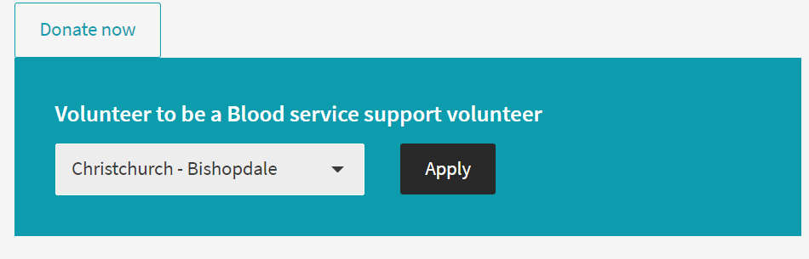

Strengths

* The color pallete is aesthetic and readable
* You can select the nearest hospital to you before inputting any other information,
* Has an easy to find donate button and easy to follow application form
* The wording throughout the application is clear and concise, most people would have no trouble understanding the given information
* The site Has different application forms depending on the hospital you select (this could be useful making different account types)

Weaknesses

* When signing up to the red crosses blood donation there are quite a few tick boxes. It can be hard to use things like tick boxes for people with tremors, parkinsons, and bad eyesight. tremors can also be related to illnesses that need blood transfusions. (people that are likely to use sites like these and more or less our target audience)
* The apply tab is difficult to find being at the bottom of the page
* The color changes throughout the page (the headers at the top of the page are all red) i'm not sure if there is any reasons for this but it feels unnecessary and harder to read
* Only mentions the covid climate late in the account creation process, i think this is really counter intuitive, especially for anyone unvaccinated due to immunodeficiencies only finding out they can't donate blood